FOR IMMEDIATE RELEASE CONTACT
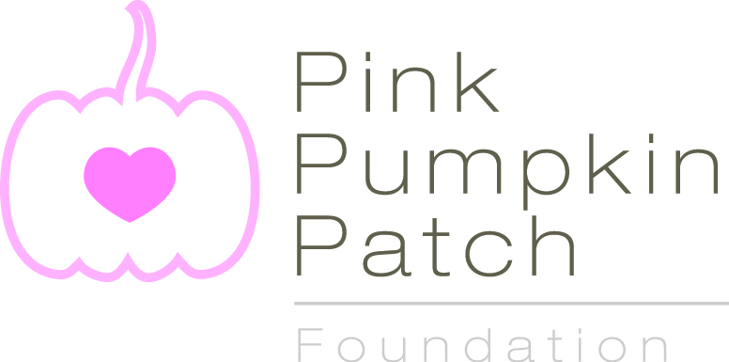
Jen Velasquez
Golden Sun Marketing
jen@goldensunmarketing.com
813.254.0769
Pink Pumpkin Patch Foundation Joins Forces with Bake It Happen
Together They Raise Awareness and Money for Breast Cancer Research

Rocky Ford, CO., September 2014 –Heading into its third season, the Pink Pumpkin Patch Foundation is fully geared up to welcome breast cancer awareness month. The foundation will continue working with commercial growers, FFA and 4H chapters across the country to promote pink pumpkins and raise funds for breast cancer research. Additionally, they have announced a new partnership for 2014 with Bake It HappenTM, a national baking campaign that raises money for breast cancer research.
The foundation debuted in the fall of 2012 with pink pumpkin growers across the country offering these unique pink pumpkins to their customers. In 2013, FFA and 4H chapters throughout the nation were offered free seed from Porcelain Doll seed distributor Seedway, as a way for students to meet their Supervised Agricultural Experience (SAE) requirement and as a way for them to contribute to breast cancer research as they planted, harvested and sold their crops.
This year the foundation has garnered new energy by partnering with Bake It Happen. The campaign is unique in that the request for its participants is reasonable; no one is asked to personally solicit for money, to run in a race, or climb a mountain. It’s really quite simple, fun and anyone can participate: just bake and share a baked item with the people in your lives throughout the month of October.
Starting September 26th, participants will be encouraged to go to the Bake it Happen website to get access to recipes from Judy-- the mother of the two-sister team behind the Bake It Happen campaign who died of breast cancer. She is also the inspiration to the popular food blog My Judy the Foodie.
Throughout the month of October, participants are encouraged to bake the recipes and share them with anyone in their lives. Every time a recipe is baked/shared, participants take a photo and either upload it to Facebook (or social media of their choice) or email it with the hashtag #bakeithappen. Each time a picture is taken and shared, an anonymous donor will donate money to the Pink Pumpkin Patch Foundation, through Bake It Happen.
“When the Bake It Happen team approached the foundation with this creative opportunity, we were honored to be the recipient of their efforts,” said Carol Holsopple-Froese, president of the Pink Pumpkin Patch Foundation. “As a breast cancer survivor myself, I am touched by this beautiful tribute to their mother which will help us make an impact in breast cancer research.”
While the multitude of campaigns throughout October won’t bring back those lives lost, they help bring awareness and funds to breast cancer research.
“Although it won’t bring our mother back, my sister and I have found a small bit of comfort in creating a program that not only raises awareness but also directs funds to support research for this insidious disease, said Shari Brooks and Stacy Pagan, the sisters behind Bake It Happen. “We are thrilled to be able to contribute to the Pink Pumpkin Patch Foundation through our campaign efforts knowing that 100% of the money raised will be ear-marked for breast cancer research.”
For additional information about the Pink Pumpkin Patch Foundation and its pumpkins, please visit our website at www.PinkPumpkinPatch.org. For additional information on Bake It Happen, please visit their website, www.bakeithappen.net, which debuts on September 26.
# # #

About the Pink Pumpkin Patch Foundation
The Pink Pumpkin Patch Foundation was created in 2012 to aid in the fight against breast cancer. The foundation is made up of America’s pumpkin growers have committed to giving a percentage of proceeds from every pink pumpkin sold to organizations involved in breast cancer research. The foundation will oversee the donations and ensure that the funds go directly to reputable organizations with the highest percentage of dollars spent on actual research.

About Bake It Happen
Bake it Happen™ is a national campaign that was created in 2013 in loving memory of Judy Levin --- an avid cook--- who passed away after a long struggle with breast cancer. The goal of the campaign is to creatively raise money and awareness for breast cancer research through baking. Participants are simply asked to bake and share their goods with friends and family; every time goods are shared, money will be donated to a particular organization committed to the advancement of breast cancer research.

